Grower Accounting User Guide

Version 5

# Overview

This document is a guide to explain the different pages in the Grower Accounting system and how to perform basic tasks in them.

# Grower Master List

The Grower Master List is a central page for managing the list of grower master records within the Grower Accounting system. There are four types of growers maintained in the system – Breeders, Broilers, Corporate, and Miscellaneous. From the master list page a user can find any grower that needs to be maintained as well as reach pages to perform updates/edits. This page can be reached by clicking on the Grower tab in the main menu and then selecting “Grower Master List”

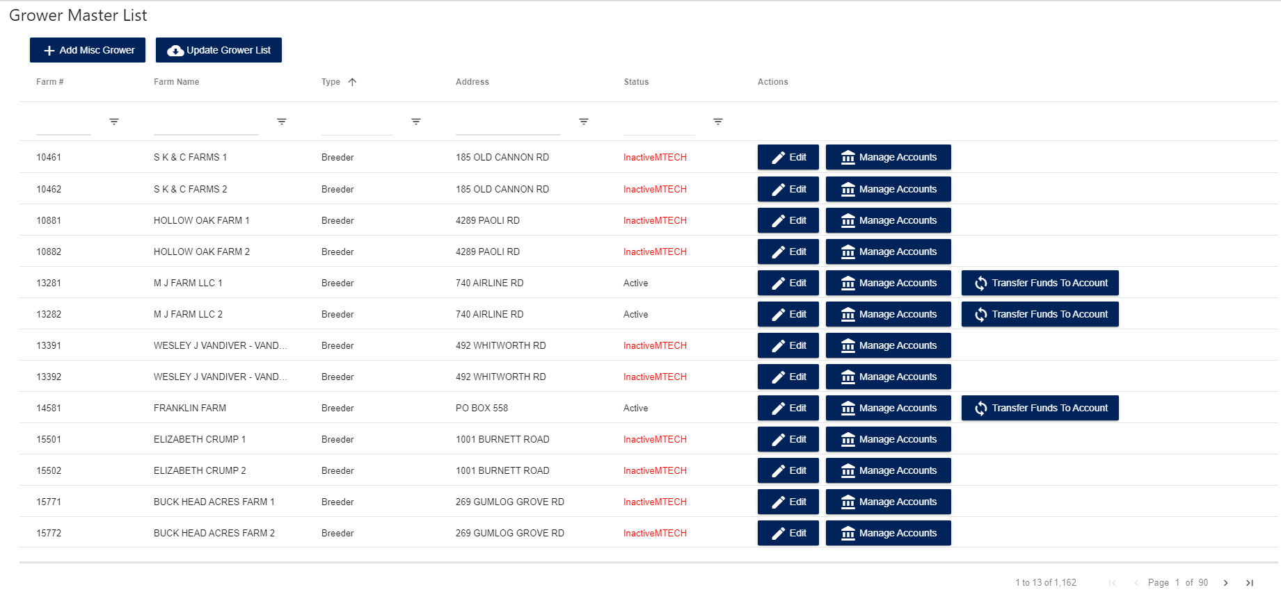

## Add a New Miscellaneous Grower

A user can only add a miscellaneous type grower (the rest are added in other systems). In order to add a new miscellaneous grower the user can just click the “Add Misc Grower” button which will take them to the add/edit screen. From there the user can enter the grower’s information and click “Submit” to save the grower to the grower master list.

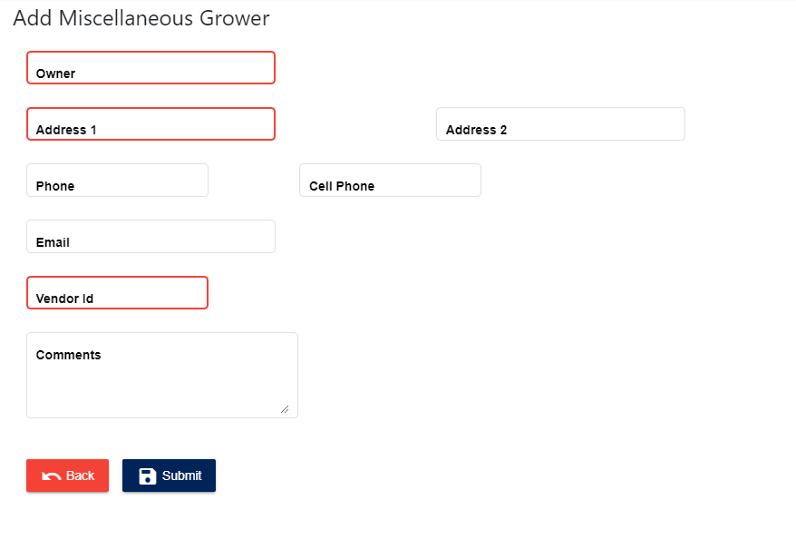

## Edit an Existing Grower

Any type of grower can be edited by clicking on the “Edit” button on their row of the main grower master list. From there the screen will look like the “Add Misc Grower” screen but with some small differences.

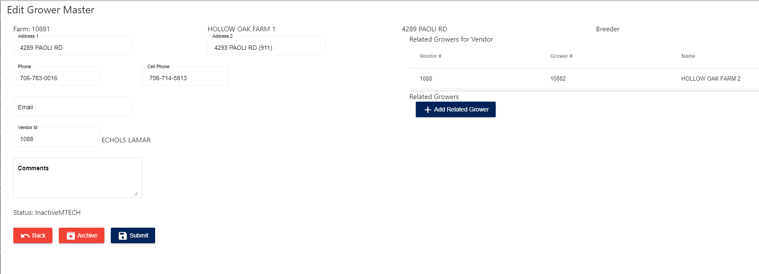

For non-miscellaneous growers in the system, only the “Comments” section can be edited. Additionally, any grower can be archived by clicking on the “Archive” button. This will mark the grower as inactive and remove it from the list of selectable grower master records.

On the right-hand side of the page is the related growers list. This features by default will relate any grower master records that belong to the same vendor, but can also be used to add any relationships between growers that might need to be created. The grower relationship is used for determining which accounts are available for a grower to transfer to or from, either in the settlement process or during a manual transfer process.

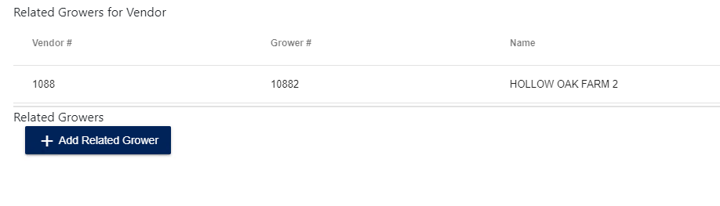By clicking on the “Add Related Grower” button, a popup window will open which will show a list of all available growers to select from

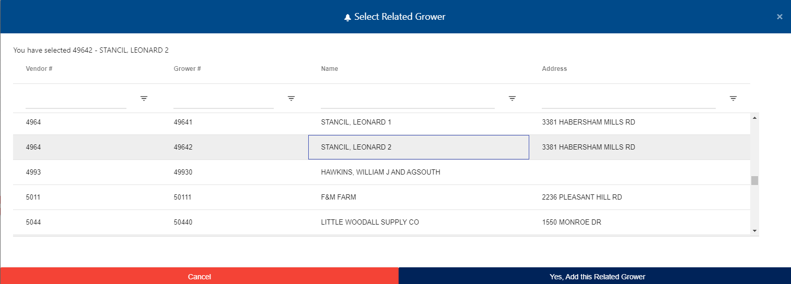

By clicking on a row and then clicking “Yes, Add this Related Grower” it will tie the currently edited grower with that selected grower and generate a link between them for transfers.

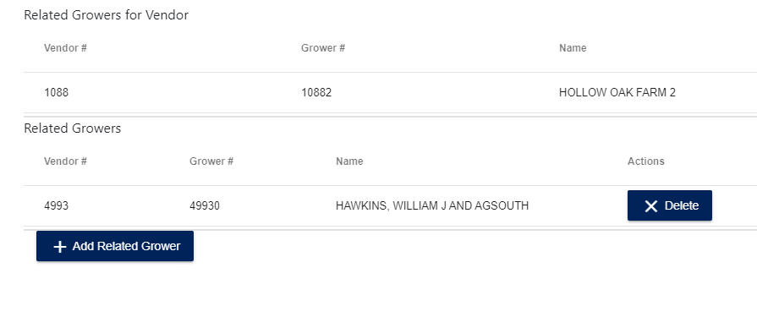

These created relationships can be deleted if needed and multiple relationships can be added as well.

## Sync Grower List

Clicking the “Update Grower List” button on the main list page will trigger a sync event for the system, which will pull in any new Grower Master records that might be missing from MTECH and the AS400 as well as any related account balance data for those growers.

## Manage a Grower’s Accounts

By clicking the “Manage Accounts” button on a grower’s row in the grower master list, the user will enter the Account Maintenance screen for that grower.

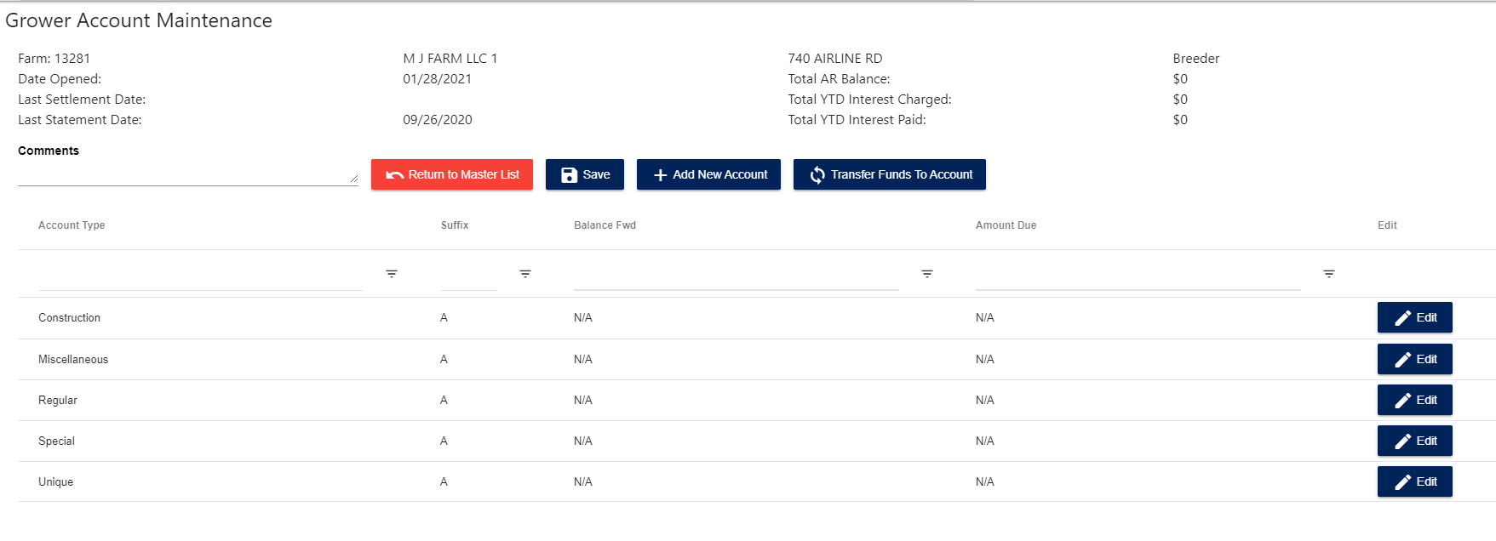This screen shows all the accounts that exist for that grower, as well as their current balances. A grower can have the following account types dependent on what grower type they are – Construction, Miscellaneous, Regular, Special, Unique. From this screen a user can add a new account (if the grower is active), edit an existing account, initiate an account transfer, or add comments for the grower.

## Add/Edit a Grower Account

If a user clicks “Add New Account” on the Grower Account Maintenance Screen a popup will open up that gives the user an option to choose an account type to make the new account for-

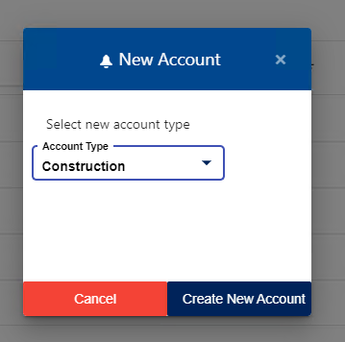

The account suffix will be the next available one (starting at A, then B, then C, and so on). Then for both Add or Edit the user is directed to another screen. If the account type is Regular or Miscellaneous then a simple screen is displayed that shows read-only information for most account fields but does allow adding or editing any comments for the account.

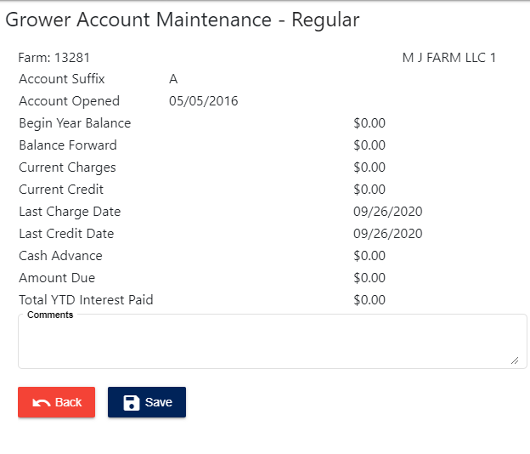

For all other account types a more complex screen is displayed which has additional fields to edit. The user can edit the information used to determine interest payments for the account.

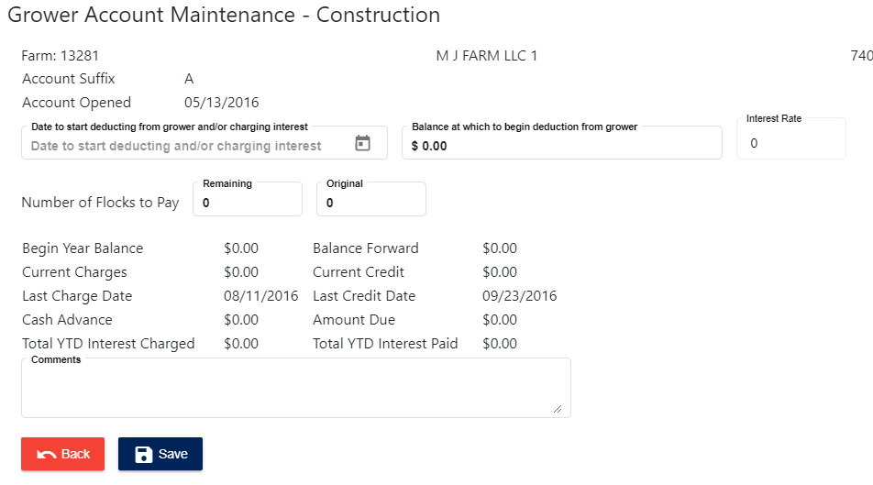

## Transfer Funds Between Related Grower Accounts

If a user clicks the “Transfer Funds to Account” button they will be directed to a screen to enter the transfer information. In order to initiate a transfer the user must select which account to transfer to, as well as which grower and account to transfer from. If needed an unrelated grower can be selected by clicking on the respective button. There must be enough available funds to process the transfer, else the user cannot submit it. A submitted transfer will process 2 transactions, a credit and a debit to the respective grower accounts and then post those transactions so the account balances are updated.

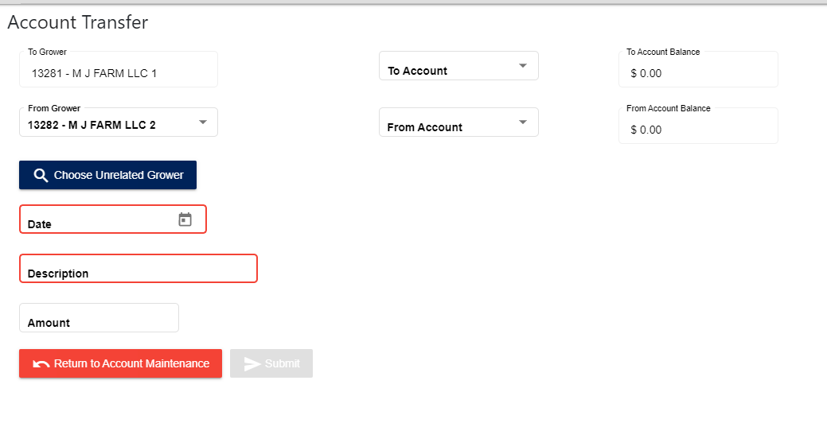

# Grower Bonus Payments

The Grower Bonus Payment page can be reached by selected “Bonus Payments” under the Grower menu link. This page allows a user to upload a spreadsheet of bonus payments in the format shown on the following image, which is the second tab of the spreadsheet with 3 columns – Farm Number, Farm Name, and Grower Bonus

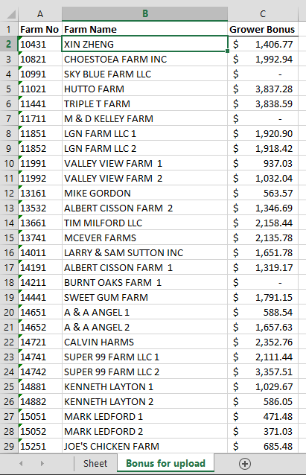

The user can upload the spreadsheet by clicking on the “Choose File” button which will automatically process and log the grower bonus payments. These payments will be useful for part of the Grower 1099 process.

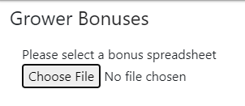

# Grower 1099s

The Grower 1099 page can be reached by selecting “Grower 1099s” under the Grower Menu. It gathers totals for any 1099 related transaction data, settlement data, and bonus payment totals.

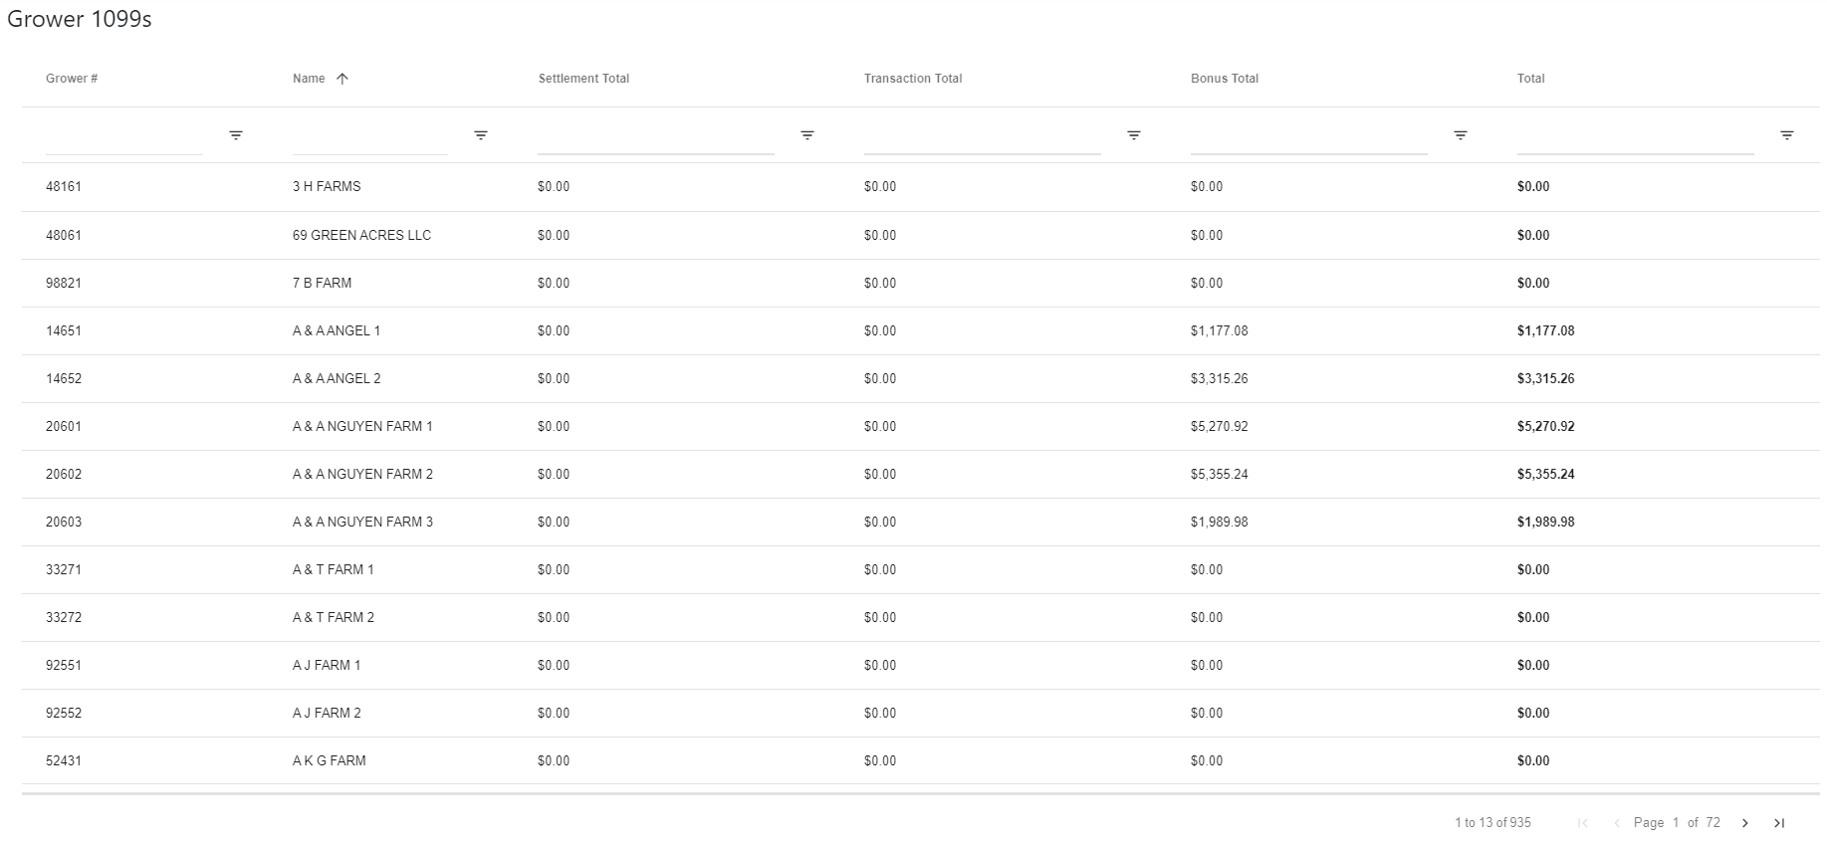

# Transactions

Transactions are a key component of the Grower Accounting system. Transactions are how various types of actions are taken that are applied to a Grower Account that can modify its balance, such as a credit or debit or interest payment. It is also where transactions recorded in the LP Gas and PCS Store systems are logged into Grower Accounting and processed against any relevant grower accounts.

## Transaction Batch List

By clicking on the “Manage Transactions” link under the “Transactions” tab of the main menu, the user will enter a page that lists all of the transaction batches in the system. Transaction batches are a collection of related transactions that are either automatically generated in the case of imports or manually created by a user.

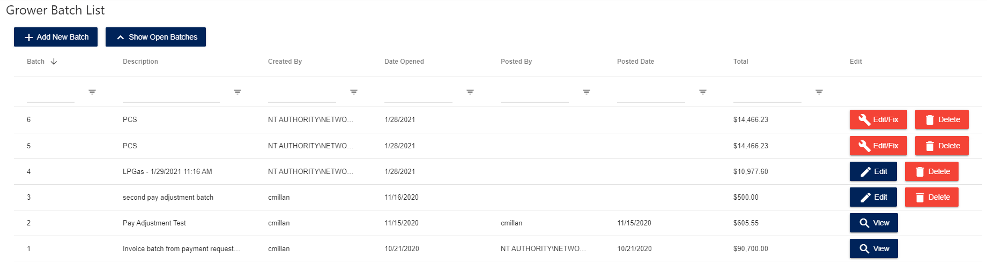

From the batch list a user will see a list of all currently open transaction batches in the system, with the most recent ones at the top of the list. Clicking on the “Show All Batches” button will show batches that have already been posted and clicking on the button again will hide them.

Each individual batch will have different options for action. If the batch has any transactions that have errors in them, such as an invalid grower number, then the batch is marked with an error status and the button to view the batch will show up as “Edit/Fix” in red. For normal open batches only a blue “Edit” button will show in that spot. Open batches can also be deleted by clicking the ”Delete” button and then posted batches cannot be modified, so they can only be viewed with the “View” button.

If the user clicks the “Add New Batch” button, a small popup will open that allows them to enter a description for a new user created batch.

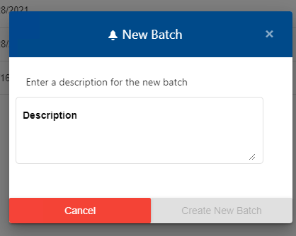

## Viewing a Transaction Batch

By clicking on the edit or view button for a batch, the user will arrive at a page containing a list of all the transactions for that batch. If the batch contains error transactions, they will be highlighted in red and a button will be available to filter down the list to only transactions with errors in them called “Show Only Error Transactions” which can be corrected by clicking on their edit buttons or deleting them from the batch (will be discussed in another section). A batch with errors cannot be posted until all errors are corrected.

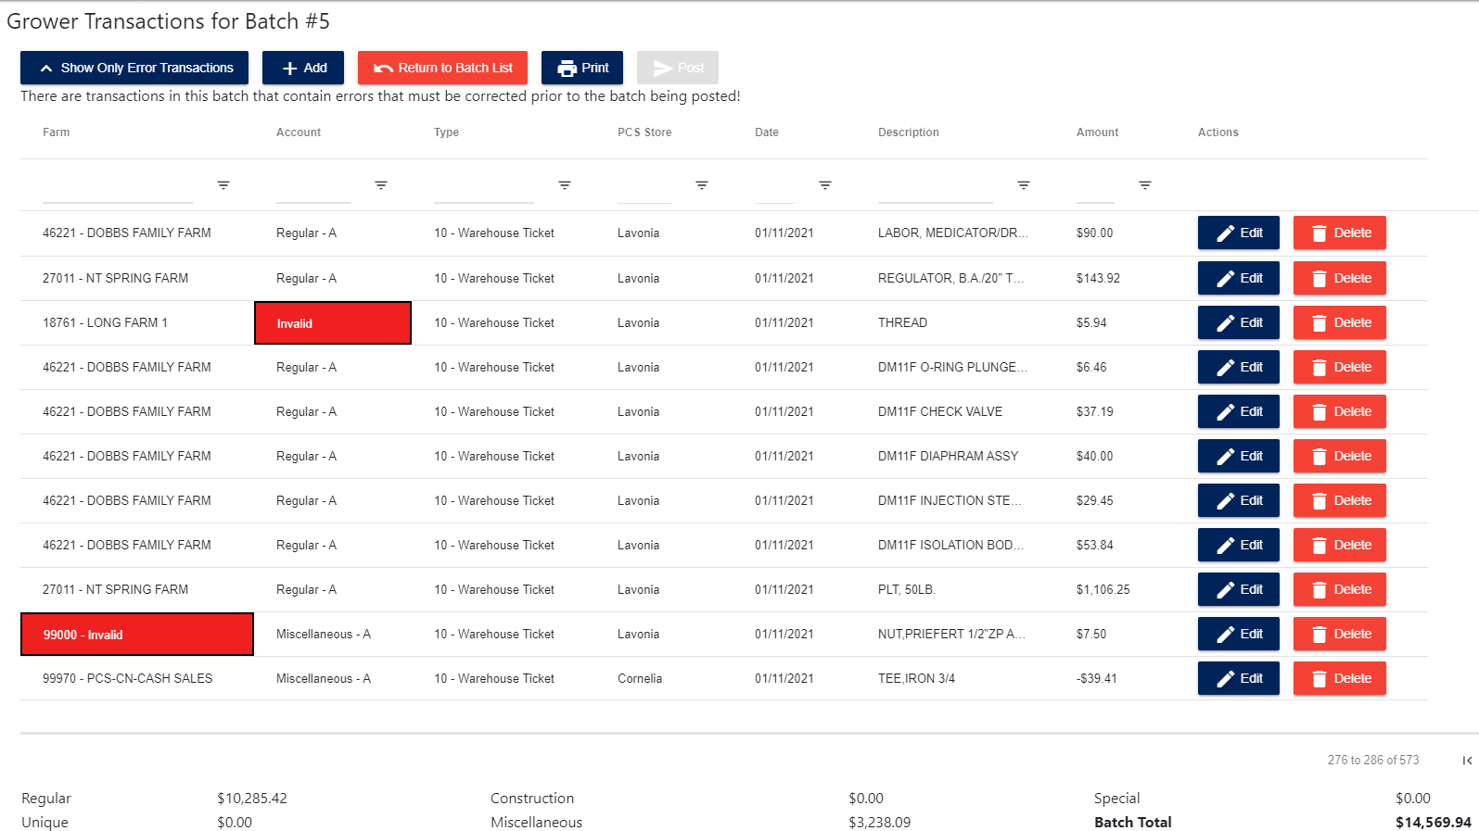

Once all the errors are corrected, the batch can be posted against the related grower accounts and close the batch from further modification. Additionally, the batch can be printed by clicking on the “Print” button which will generate a printer-friendly version of the transaction batch and all its transactions

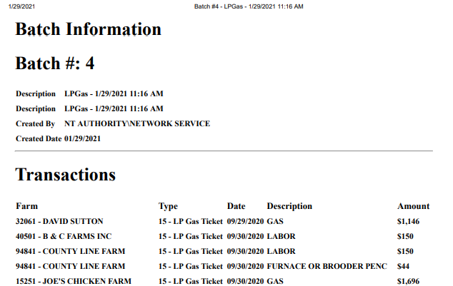

If a user wishes to add any new transactions they can do so by clicking on the “Add” button, which will take them to the next page. A posted batch cannot have any new transactions added to it, it can only be viewed for printing and historical purposes

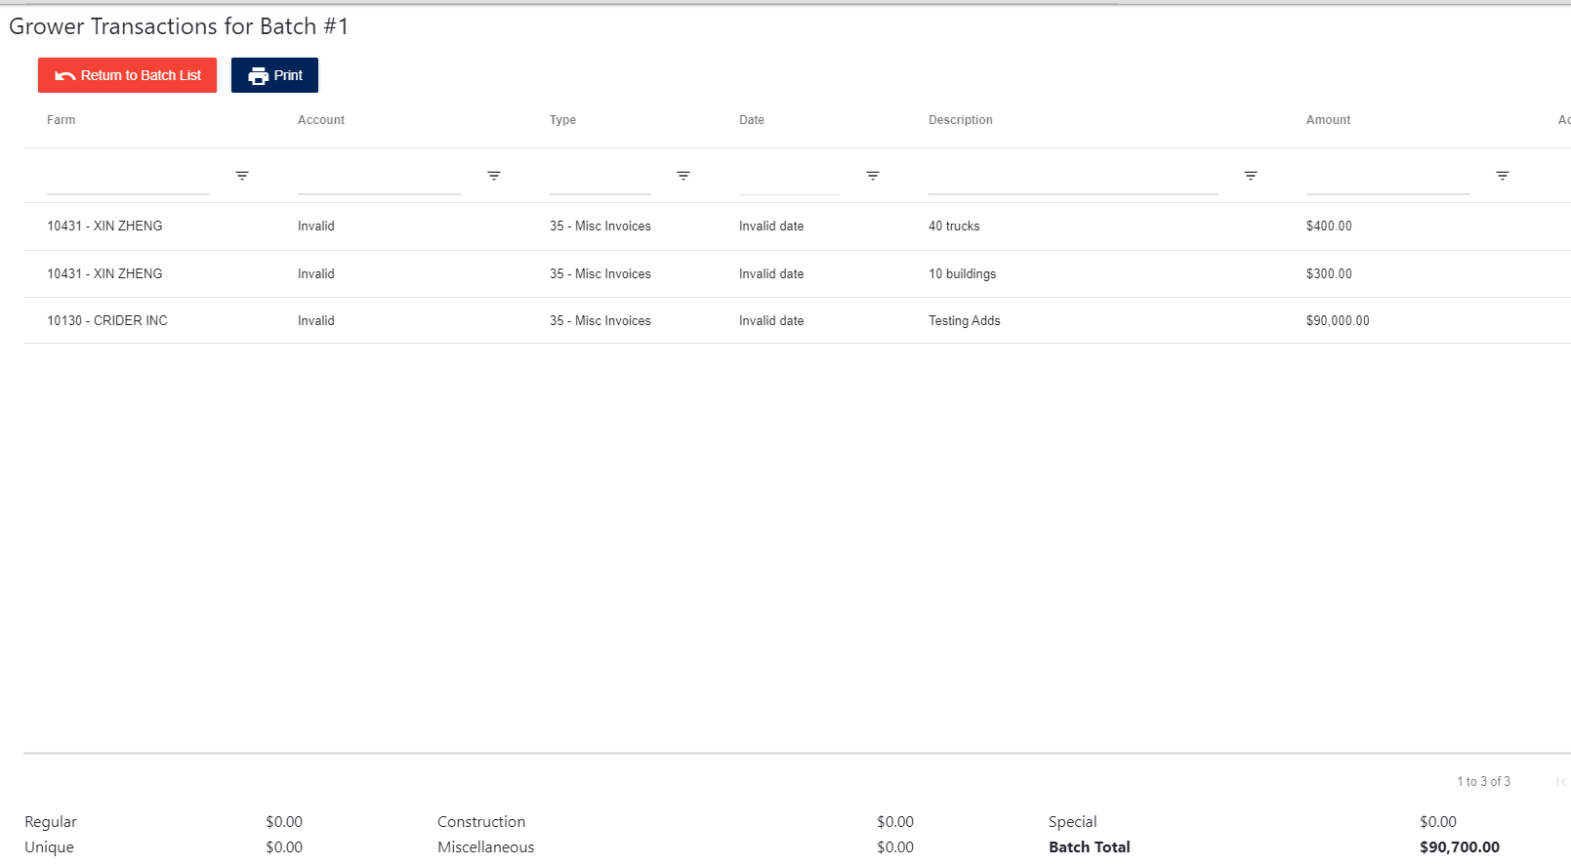

## Add/Edit Transactions

When a user chooses to add a new transaction, they are directed to a screen where they can search and select a grower from the main grower master list

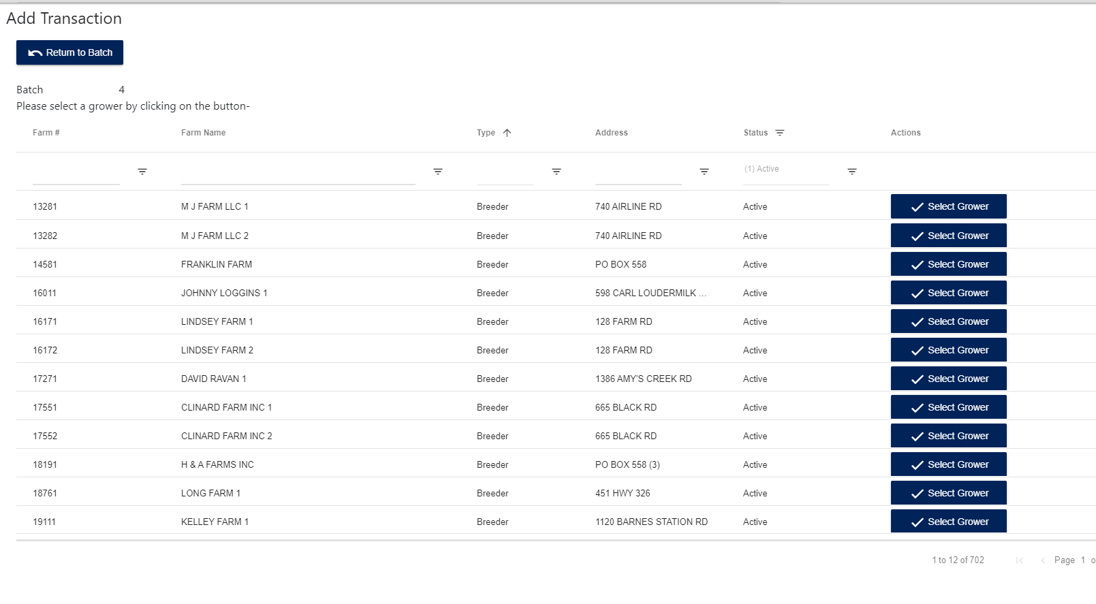

Once the user selects a grower by clicking the “Select Grower” button it will direct them to a separate screen where both add and edit transaction take place. The user can also make corrections to the grower number and account if it is an error transaction.

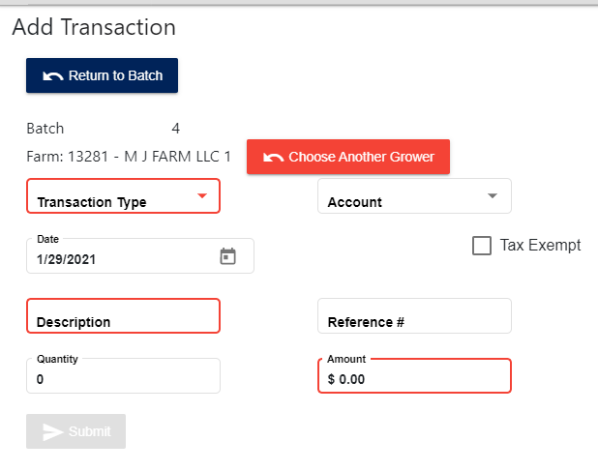

The following table is a list of the different transaction types available

|  |  |  |
| --- | --- | --- |
| Code | Transaction Type | Description |
| 10 | Warehouse Ticket |  |
| 12 | Poultry Purchase | Grower purchases fresh or frozen product from a Fieldale plant. |
| 15 | LP Gas Ticket | Import, edit and post LP Gas Deliveries. |
| 20 | A/P Advice Slip | Used to enter miscellaneous charges or credits from a Fieldale Manager’s Advice Slip. Also used to enter AP Payments made to vendors on behalf of the grower – to record the expense (e.g. utilities) on the Grower’s AR Account. |
| 25 | Labor Advance | Enter funds provided to Grower in advance, to cover labor costs |
| 30 | Cash Advance | Funds provided to Grower in advance for cash expenses |
| 35 | Misc Invoices |  |
| 40 | Cash Receipts | Grower AR Entry – Cash Receipts. Example: Used to record daily PCS sales by cash or credit card against a farm number 99890 – PCS LV Cash Sales account. Record as negative number (reduces the grower’s expense) |
| 45 | Misc Entries | Example LP Deductions – Payroll deductions from employees that live on the farm, credit the Grower Account. Consider it advance payment on account against LP Gas bills. |
| 46 | Transfer |  |
| 50 | Flock Settlement | Settlement transaction – amount paid Grower after deductions. Record as a negative number but display positive. |
| 55 | Interest Charged | This is automatically created by settlement |
| 60 | Interest Paid | This is automatically created by settlement. Record as a negative number (reduces grower’s expense) |
| 65 | Note Payment | Bank note payment transaction* |

## Importing Transactions for LP Gas and PCS Store

While transactions can be manually entered into the Grower Accounting system, it also can import transactions from 2 other main sources – LP Gas transactions and PCS Store transactions. This page can be reached by clicking on the “Import Transactions” link under the Transactions menu tab.

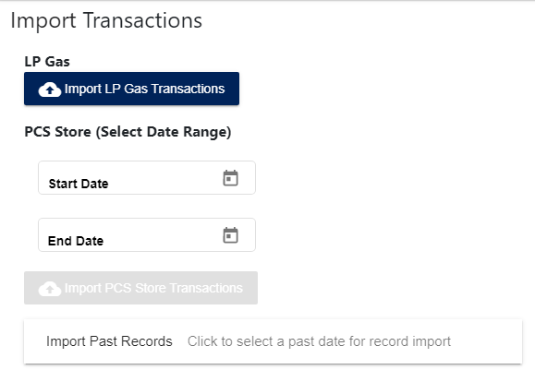

PCS Store imports will require a date range for the transactions while LP Gas imports do not.

By clicking on either button, the user will import any new transactions from the from either LP Gas or PCS Store transaction files in the AS400, which can take several minutes to process. Once it finishes, a new transaction batch will be created with all of those transactions and be in an open state unless there are grower master and/or account errors, in which case the status will be Error.

If a user wishes to import non-current data they can click the Import Past Records “button” which will open up a new window-

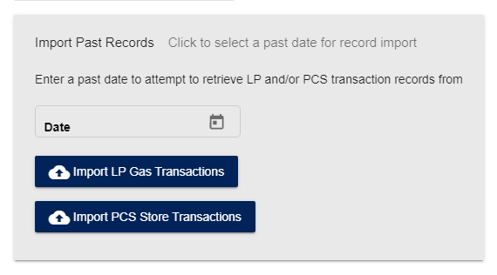

The date selected will attempt to import any transactions that might be found for that date that were captured during the automated transaction “capture” process, which will save snapshots of both the LP Gas and PCS Store transaction files throughout the day. Due to the nature of this process these batches might need some additional user cleaning to eliminate any duplicate items.

## Transaction Inquiry

If a user wishes to see the transaction history for a specific grower, they can select “Transaction Inquiry” from the Transaction menu. The page will show a grower selection screen like the one used for adding and editing transactions

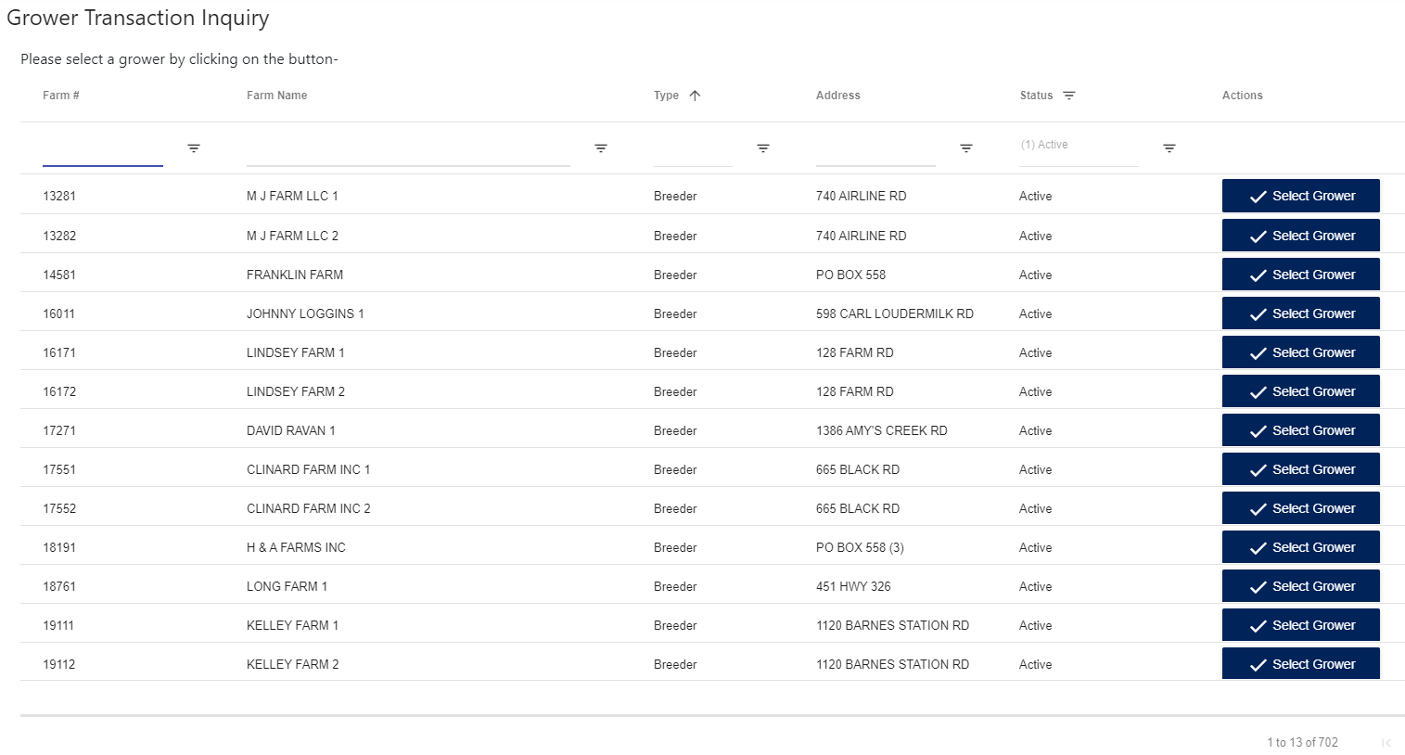

After the user selects a grower, the page will load any transactions that that grower has

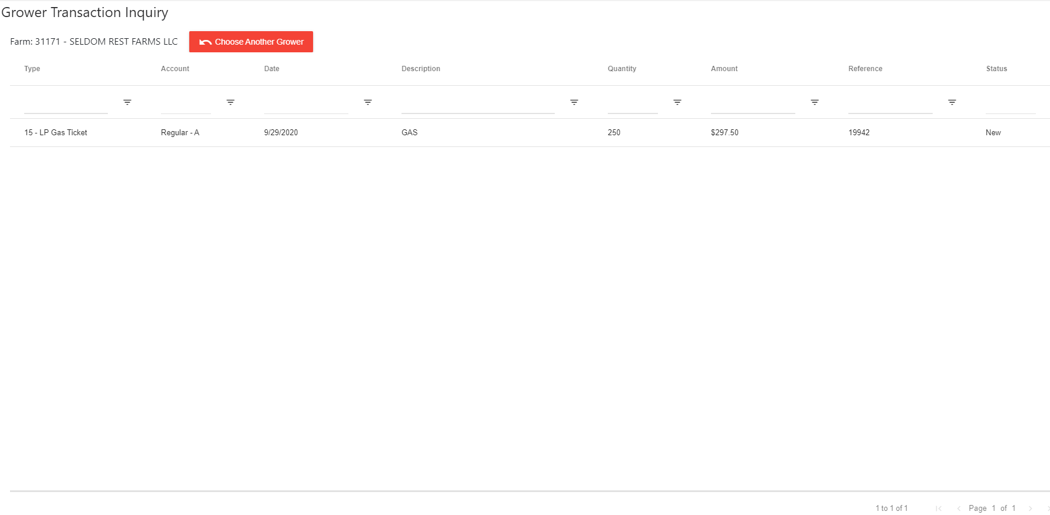

## Tax Exempt Transactions

Tax exempt transactions can be accessed by clicking on Tax Exempt Transactions under the Transactions menu in the banner. The first screen is a small search screen which gives the user the ability to set a date range to retrieve all tax-exempt transactions. By default this range is 1 full calendar

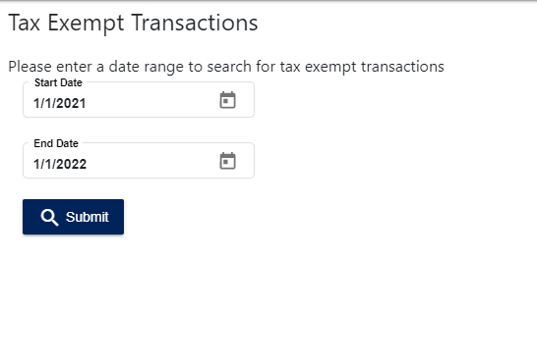

After the user selects the desired date and hits submit the system will search for all transactions run for that date range that are also tax-exempt, and then returns them in a searchable table format. Additionally the user can download a spreadsheet version of that data 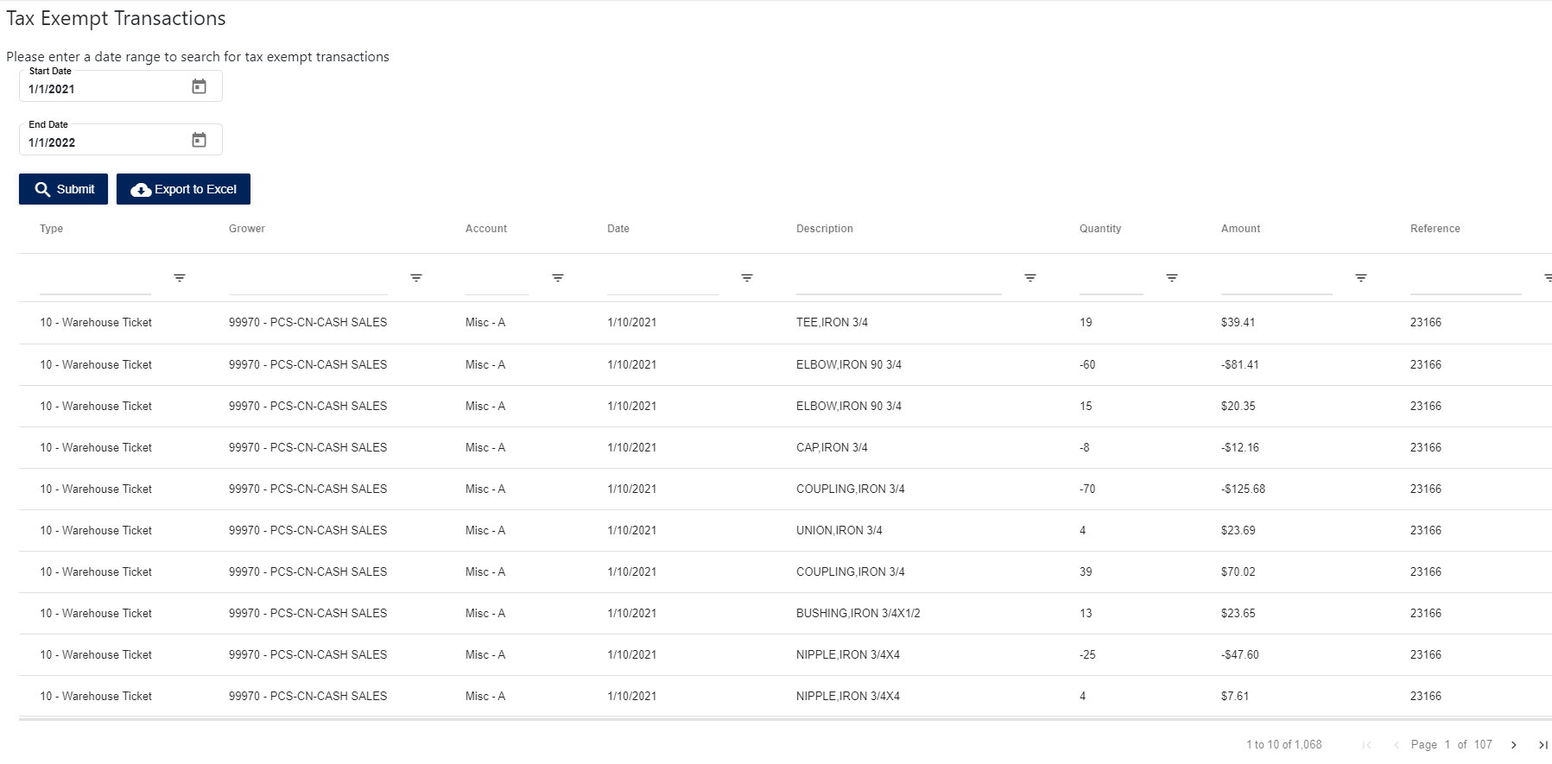

## Account Transaction History

The account transaction history page allows a user to view the transactions that have been posted against the account that lead to the current balances. To access the page simply select “Account Transaction Inquiry” under the Grower or Transaction menus. The first page will allow a user to select a grower, and then the page will display a list of its accounts to choose from.

## 

After selecting the account the user wishes to view, the page loads a list of all of the transactions that have been posted to that grower account as well as the account’s current balances.

## 

# Grower Bank Notes

The grower bank note section can be reached under the “Bank Note” menu tab. This allows users to assign bank loans to both breeders and broilers, which will then be used during the settlement process.

## Bank Note List

By clicking on the Bank Note tab, the page will load a list of grower master records to choose from like the search table found in several other pages in the site.

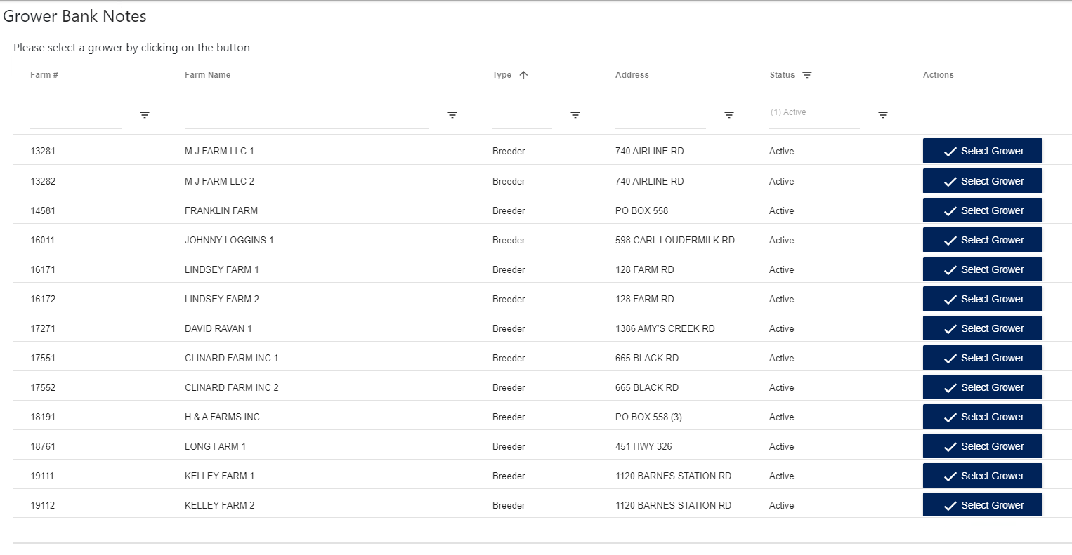

By clicking on the “Select Grower” button, the page will load a list of any bank notes that have been assigned to the grower

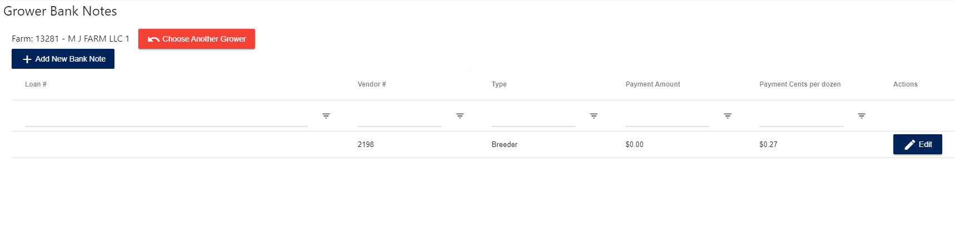

## Add/Edit Bank Note

When a user clicks on the Add New Bank Note button or Edit on an existing bank note it will direct them to a basic form where they can enter the information for the bank note. Payment terms can be selected as Net Proceeds, Gross Proceeds, or N/A. This will impact how payments are made on these loans during the settlement process.

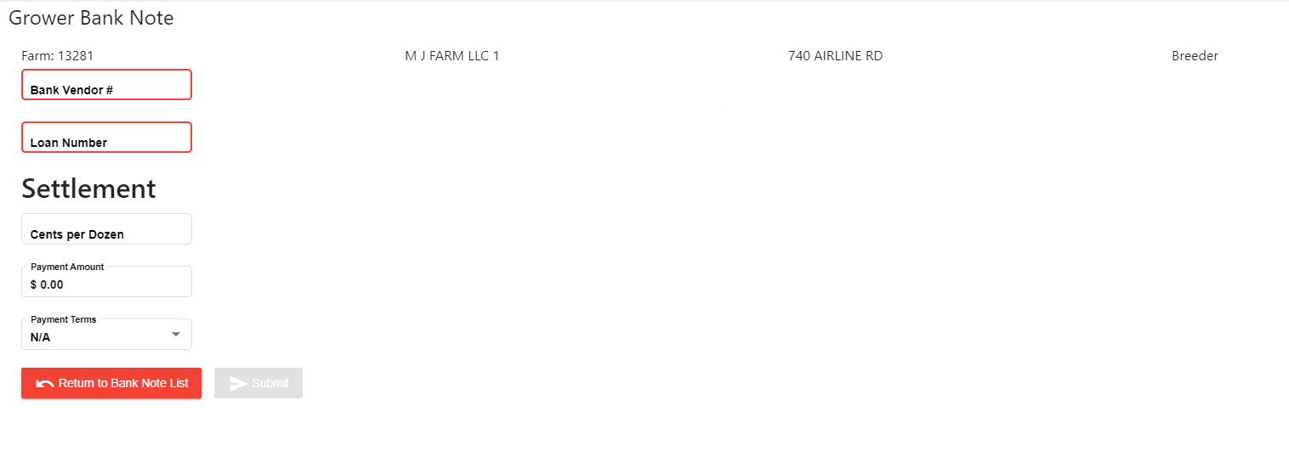

# Settlement

One of the main features of the Grower Accounting site is settlement processing. Settlements are generated in the Breeder Settlements site for Breeders and the MTECH system for Broilers, which can then be imported into Grower Accounting for the rest of processing against their related growers and accounts.

## Import Settlements

The first step in the settlement process is that settlements must be imported into Grower Accounting. To do this the user must select “Import Settlements” under the “Settlements” menu tab. The page will load with search forms for both Broilers and Breeders. Broilers settlements are imported by using a date picker, and then Breeder settlements are selected by selecting fiscal year and then fiscal period.

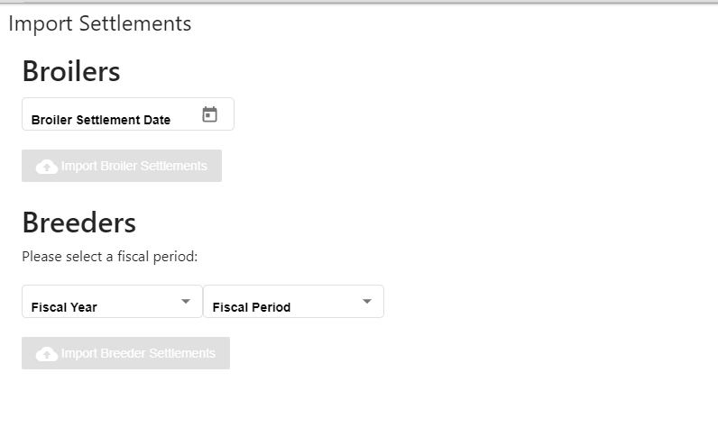

## Settlement Batch List

The settlement batch list page can be accessed by clicking “Manage Settlements” under the Settlements menu. It shows a list of all settlement batches in the system, which can also be filtered down to certain statuses.

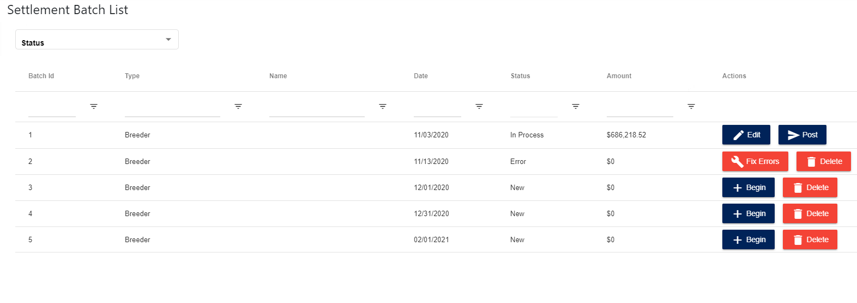

Only one settlement batch can be open for editing at a time, and it cannot be done if there are transactions currently being processed as well. This is meant to prevent multiple sources of input modifying grower account balances at the same time. If a batch has any errors in importing, which are usually invalid grower accounts, then the batch is marked as an error status (see related section for more information).

The “Begin” button will open a batch for editing by performing all of the estimated deductions, note payments, and settlement transfers needed. This process can take several minutes to complete, but it will redirect the user to the edit settlement screen once finished (see related section for more information).

Once a batch is finished with all of its settlements being above the minimum $10 requirement and all edits are made, it can be posted by clicking the Post button, which will process it against the appropriate grower accounts, process any note payments and make any invoices as needed. After being posted a settlement batch can be viewed in read-only mode or printed out.

## Fix Settlement Batch Errors

If a settlement batch encounters errors during import it must either be deleted or corrected. By clicking on the “Fix Errors” button the site will load a page listing all the settlement records in that batch that have an import error, such as invalid grower number. The user can also view the other settlements in that batch for reference, but once all values are corrected then the user can submit the fixes and the batch can be processed.

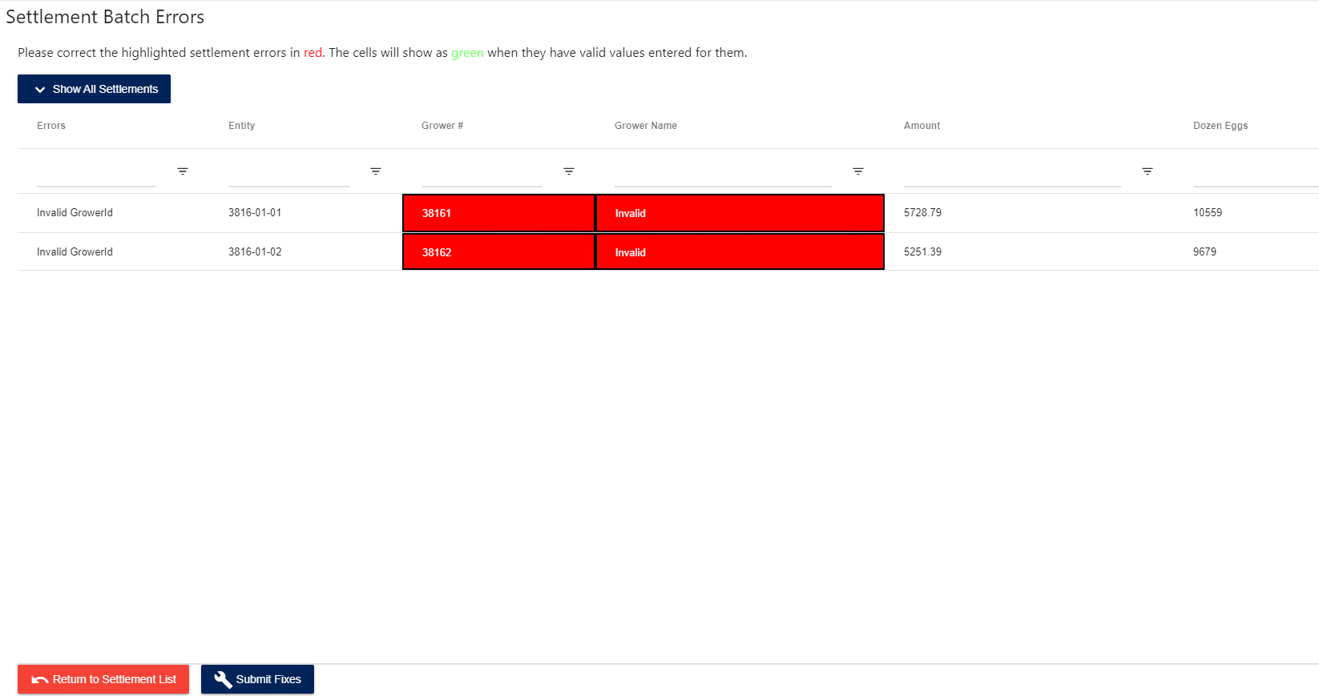

## Edit Settlement Batch

After a batch has had its initial calculations processed it redirects to the page for editing the settlements within the batch. This page can also be returned to by clicking the “Edit” button on an open batch from the batch list.

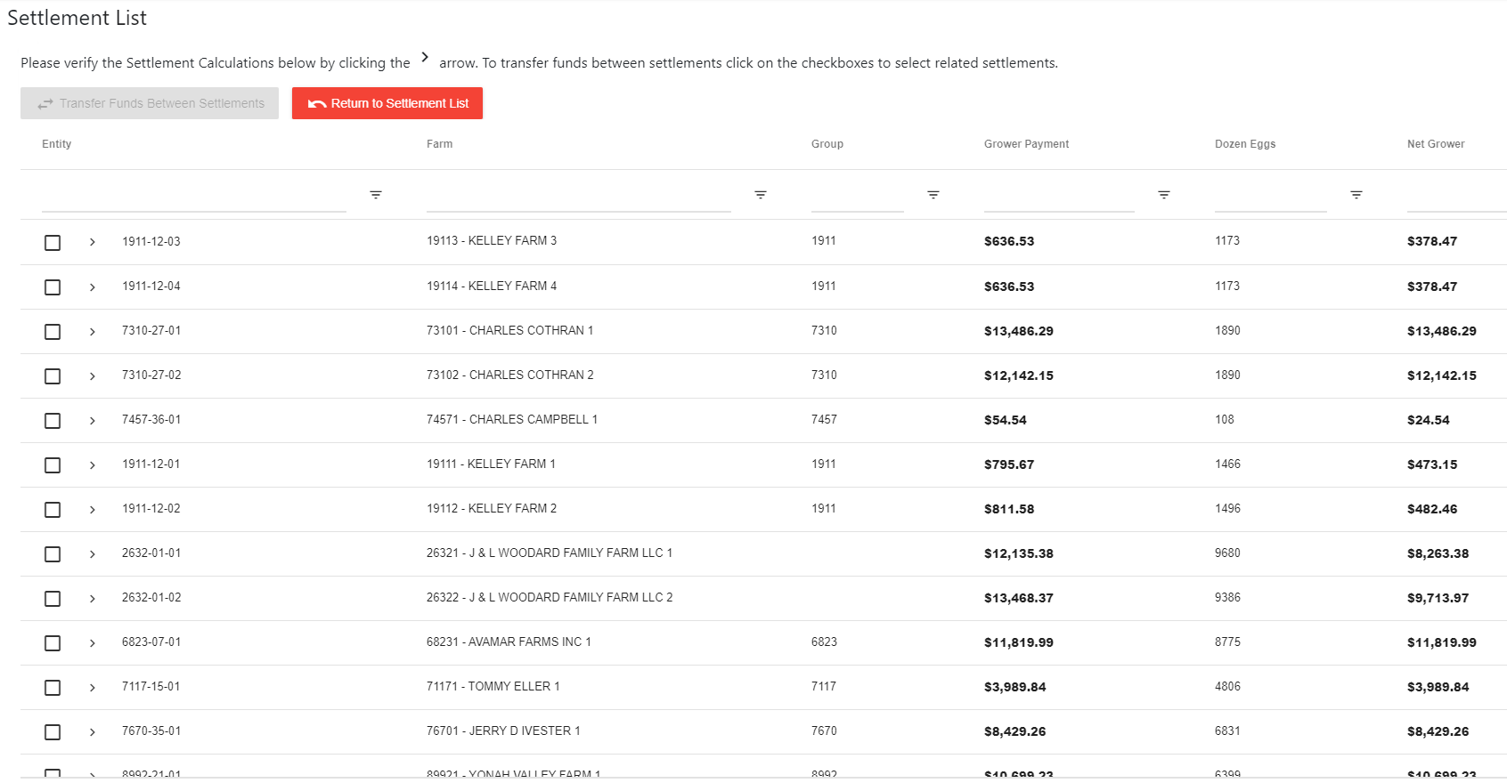

To edit an individual settlement, the user can click the arrow button located next to the entity number. This will expand the settlement to show all its deductions, note payments, and transfers that were generated during the initial processing step. The numbers can be changed as needed.

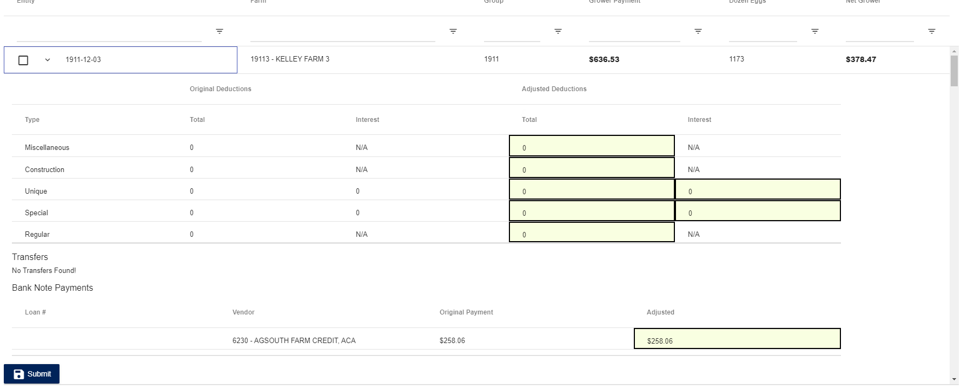

If a user needs to transfer funds between 2 settlements manually, they can click on the checkboxes located on the left-hand side of the settlements for related grower settlements and then clicking on the button “Transfer Funds Between Settlements”

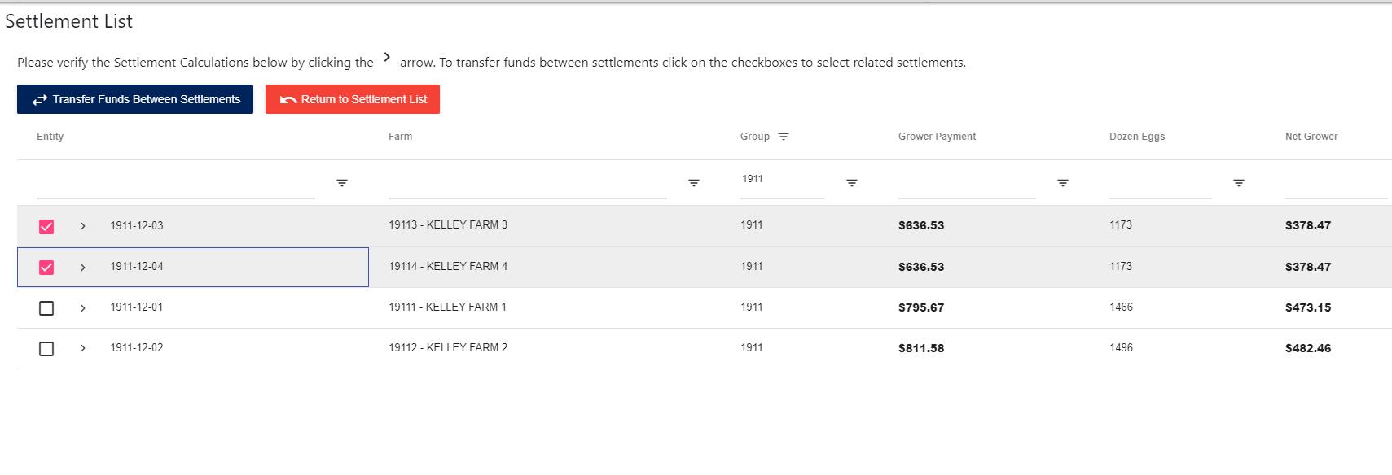

This will open a popup window that allows the user to enter how much is needed to transfer between the 2 settlements selected.

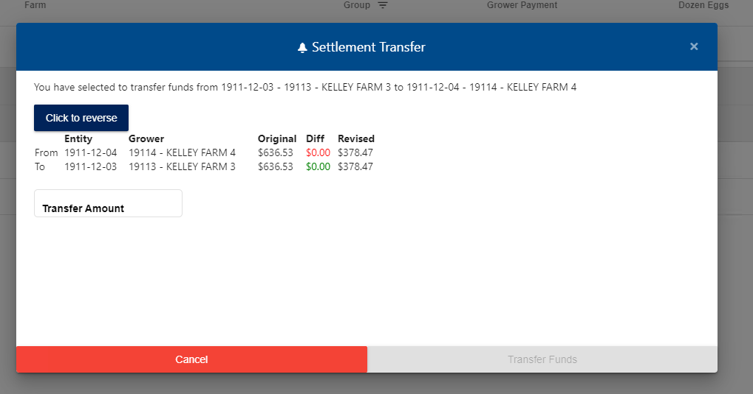

## Reset Breeder Settlement Data

As part of the annual process for Grower Accounting, the breeder balances are reset every year. To do this, the user can select the “Reset Breeder Counts” menu option in the settlement menu. Then by clicking the “Reset Breeder Balances” button the system will reset settlement data for all breeders.

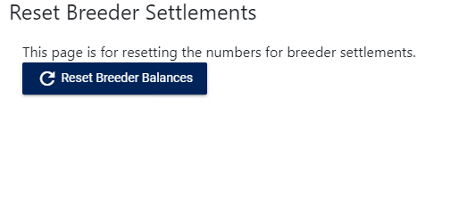

# Invoice

The Invoice section of Grower Accounting is the other main section of the site. Invoices are created for Accounts Payable and are then exported back into the AS400 and in the future into Aptean Ross. Invoices are entered through a workflow process with multiple approval steps that will be described in this section. The Invoice Workflow process consists of the following steps

* Invoice Request – Invoices are entered in batch form
* LPO Review – LPO approvers review the invoice batch and invoices within
* Accounting Approval – Accounting approvers will review the approved invoices from LPO
* Invoice Processing – Invoices are finalized for posting and processing into the general ledger

## Manage Invoice Approvers

In order to process invoices through the workflow, the system needs approvers configured for each step. The “Manage Approvers” page can be reached under the “Invoice” menu. The page will show a list of approvers for each step in the process as well as which person is the current approver at each step. Clicking the blue button next to a person will mark them as the default approver at that stage. Additionally, any user within the Fieldale Active Directory can be selected and added for an approval stage by searching for them in the Name input.

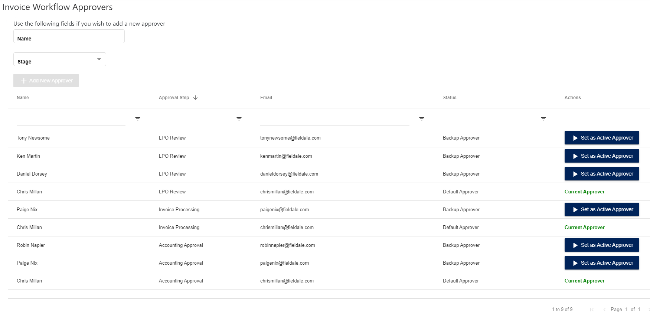

## Invoice Batch List

The first step of the invoice workflow is the invoice payment request entry. Invoices can be entered in batches, which are shown on the Invoice Batch List page. This page is reached by clicking on “Invoice Request List” under the Invoice menu.

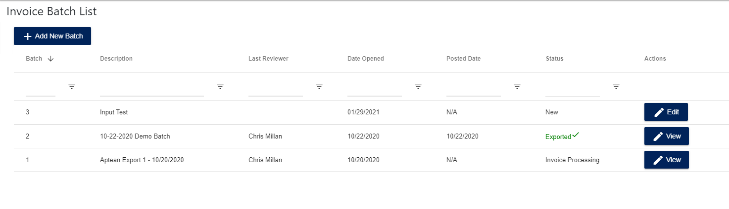

Batches are listed in order of most recent showing first. If the batch is still in the “New” status, then the user can add invoices and edit invoices they’ve added to the batch. Once the invoice has been submitted into the approval workflow it can no longer be edited, only viewed in a read only status. The user can create a new invoice batch by clicking the “Add New Batch” button and then writing in a description. By default the description is set to the current date of the user entering the invoices.

## View/Edit Invoice Batch

By clicking on the “View” button on an invoice batch, the user will reach a read-only page

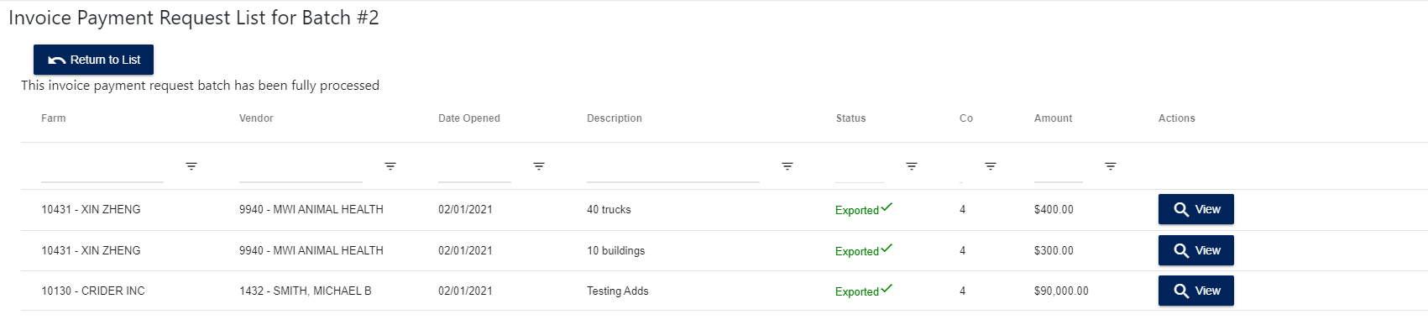

Clicking on an invoice row’s View button will show the user a read only summary of the invoice

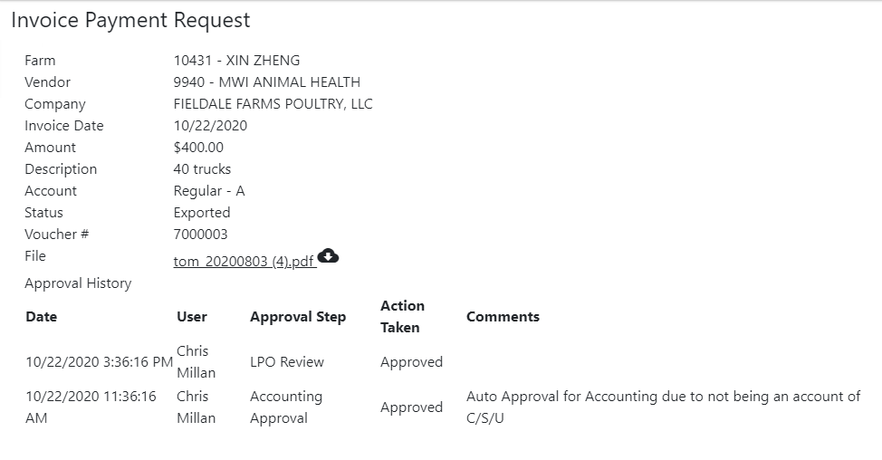

If the invoice batch is in the new status then it can have invoices entered in it. It also sets the LPO approver for the batch as the default approver set in the Manage Invoice Approvers section; however, the user can change who is the approver for that step for the individual batch.

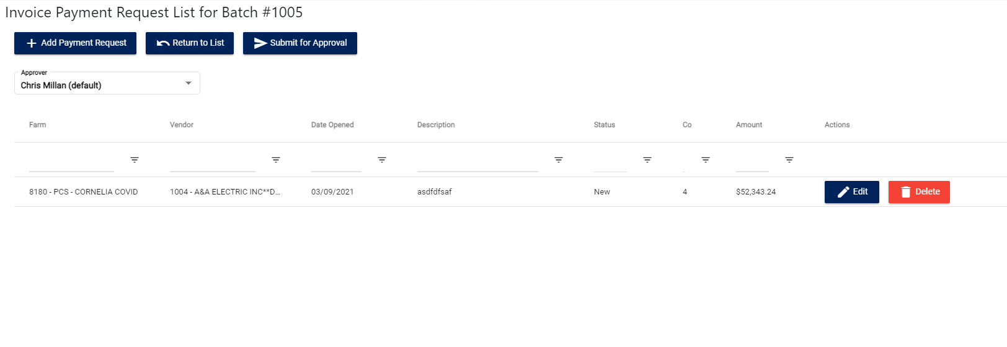

A batch must have at least 1 invoice in it prior to being submitted for approval, so by clicking the “Add Payment Request” button the user can add a new invoice. Clicking edit on an invoice will take you edit page for the invoice request, and then clicking delete will delete that request so it won’t be submitted.

## Add/Edit Invoice Request

The first step for adding a new invoice request is to select the company, grower, and vendor for the invoice. The grower and vendor can be selected by entering the number or by searching an autocomplete text field for their names.

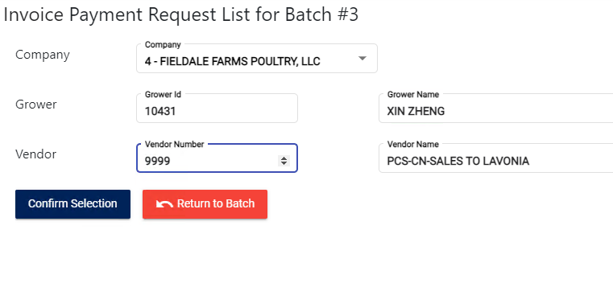

Once the user has confirmed these selections the page will render the next section of inputs. Each invoice request must include an attached file (or mark the checkbox that the invoice is exempt from having a file), often a scanned copy of the invoice itself. The user can also split the invoice into multiple grower distributions by clicking the “Distribute to Multiple Growers” button. The farm distributions most total the total amount for the invoice. Additionally, for expedited input purposes the user can click the “Duplicate” button which will duplicate the invoice information for creating a new invoice other than the invoice number and the invoice file uploaded. Clicking “Add New Request” will save and submit the request and then reload the page at the prior screen.

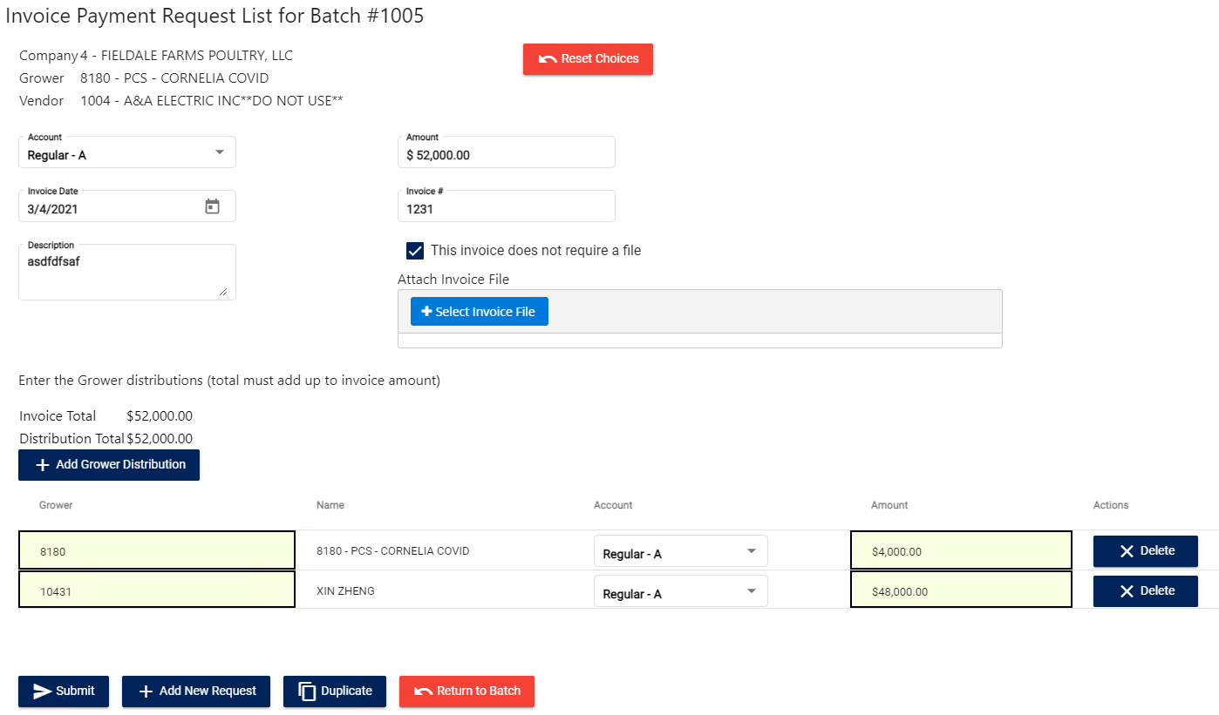

## LPO and Accounting Approval

After an invoice batch has been completed in the entry step and submitted for approval, the selected user is sent an email with a link to the approval page for the batch

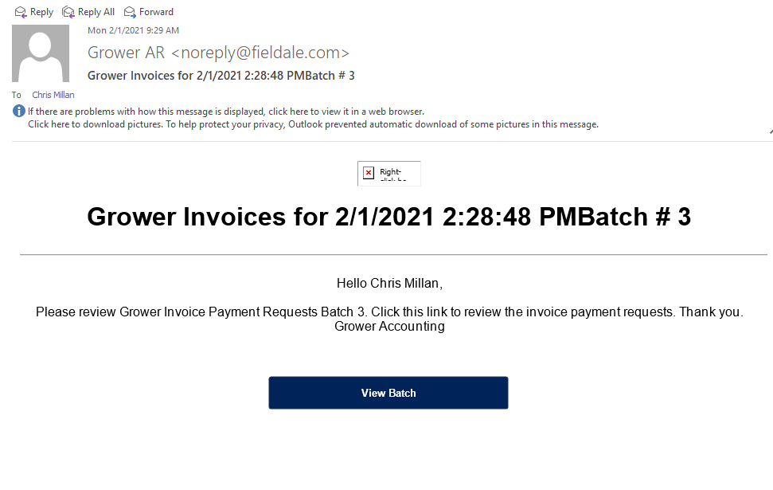

Clicking on the “View Batch” button in the email will direct the user to approval page for the batch

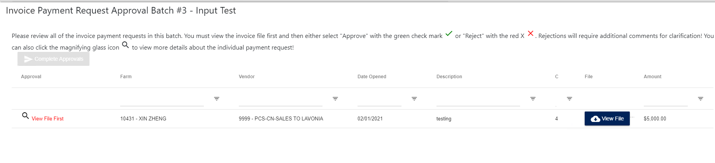

Each invoice in a batch must be reviewed prior to submitting the approval actions; however, the invoice file must first be viewed by clicking “View File” (when one exists) before the approval actions are unlocked for the individual invoice.

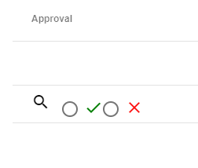

Clicking the green checkmark will mark the invoice as approved and no further action is required for it. If the user clicks the red x, then the invoice is marked as rejected and comments are required.

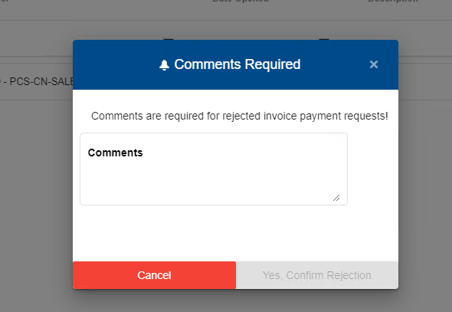

If the user clicks on the magnifying glass they can view a simple read only version of the invoice.

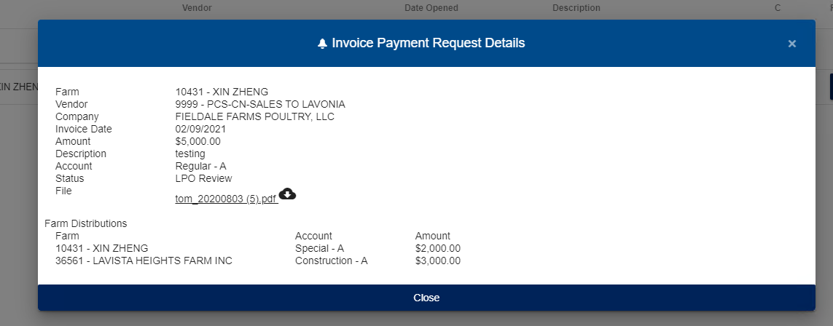

Once the LPO reviewer finishes approval actions on a batch any invoices that are written against the account types of Construction, Special, and Unique must be approved by Accounting as well, which uses the same approval screen as LPO. If the accounting approver rejects any invoices, they are returned to the LPO reviewer for further review. Once all invoices have been either cancelled or approved at their final stage required the invoice batch is moved on to the Invoice Processing stage and an email is sent to the invoice processor (managed in Manage Invoice Approvers)

## Invoice Processing

Once the invoice processor clicks on the link in their email the site will load them the list of invoices in the batch. Each invoice in the batch must be reviewed before the batch can be posted to the general ledger. This process involves converting the invoice payment requests into AP invoices. Once finished the batch can be exported to excel, printed out, or posted. It can also be deleted if needed.

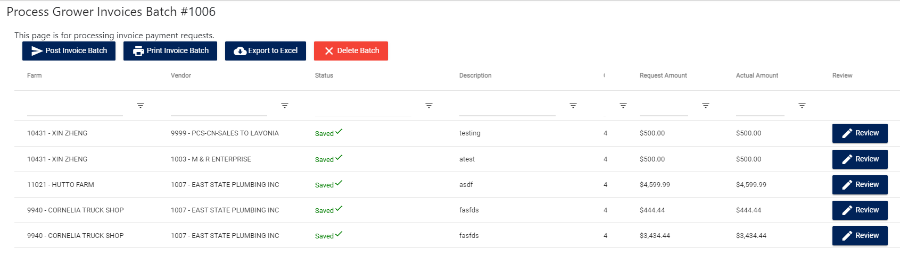

## Process Invoice

By clicking on the “Review” button for an invoice record, the user is directed to the Process Invoice page. An AP voucher is assigned for the invoice and most of the information is prepopulated from the invoice request. The user can also assign GL Account distributions. By default there is only one distribution to the main AR account for Growers – 411000.

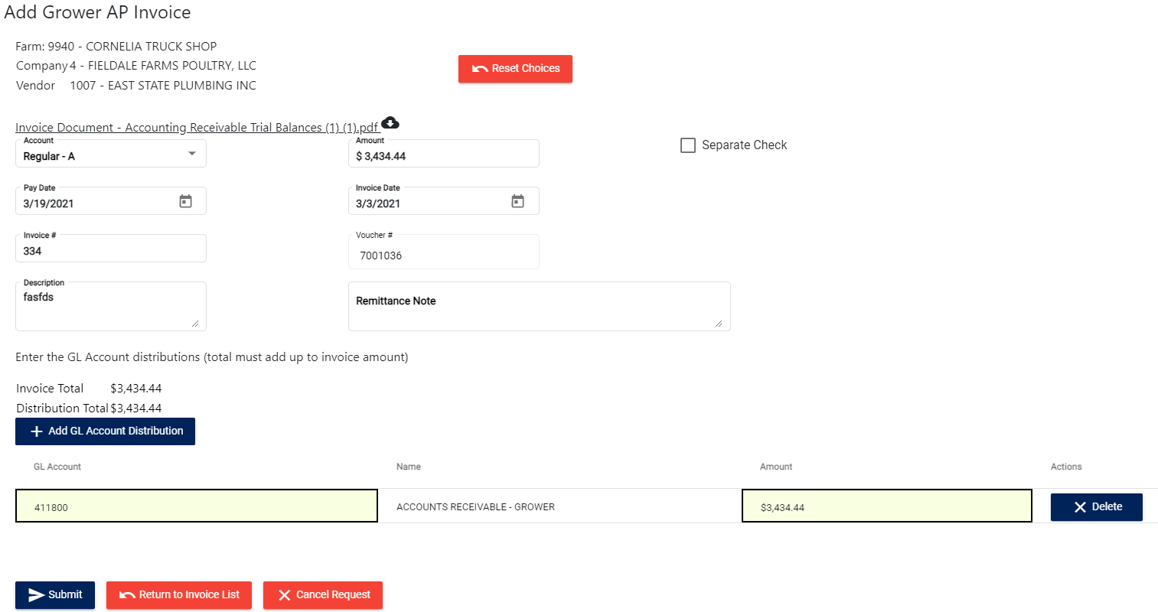

The request can also be cancelled at this step like the rejection in the approval process, and as such it also requires comments to do so. Once the user has completed the page and clicks submit, the next invoice in the batch is loaded until the batch is completely reviewed and processed. If there is a file that was attached with the request, you can view it in a link next to the line “Invoice Document”

## Invoice Search

The user can view all AP invoices in the system by clicking “Search Invoices” in the Invoice menu. The page will then show several fields that the user can narrow their search by before searching for matching invoices. If the user clicks “Sync Check Data” the system will update the invoices in the system that it can find any checks for in the AS400.

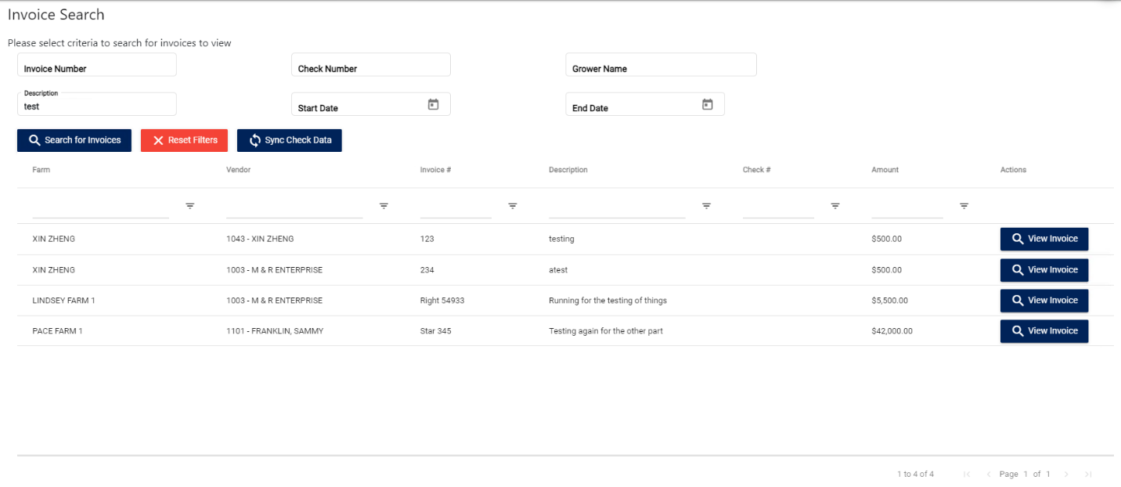

Clicking on the “View Invoice” button will display the invoice information in a small popup window.

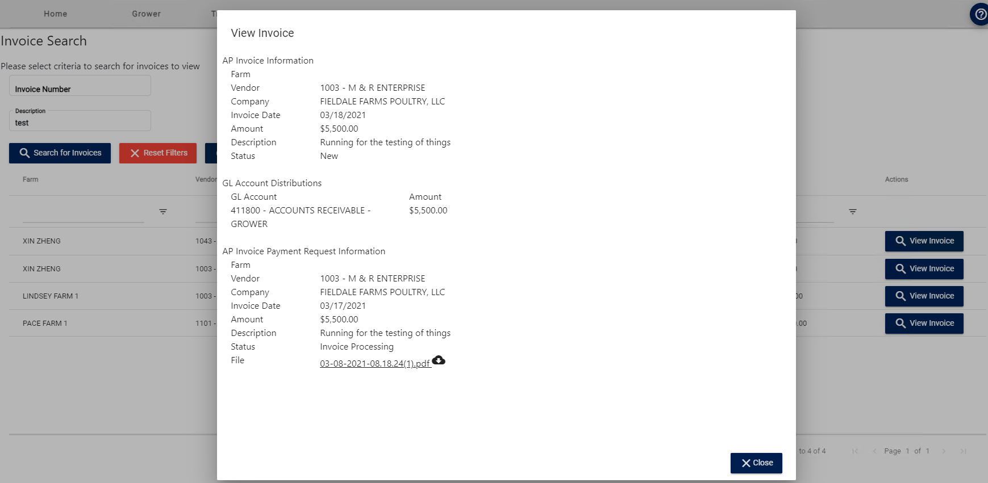

## Check Management

The Check Management page can be reached by selecting “Mark Checks as Sent” in the Invoice menu. This page serves as a report page for which invoices have alternate people to send checks to as well as a page to mark those invoices as being completed (i.e. the check has been sent). The list can also be printed out as well as exported to Excel for record keeping.

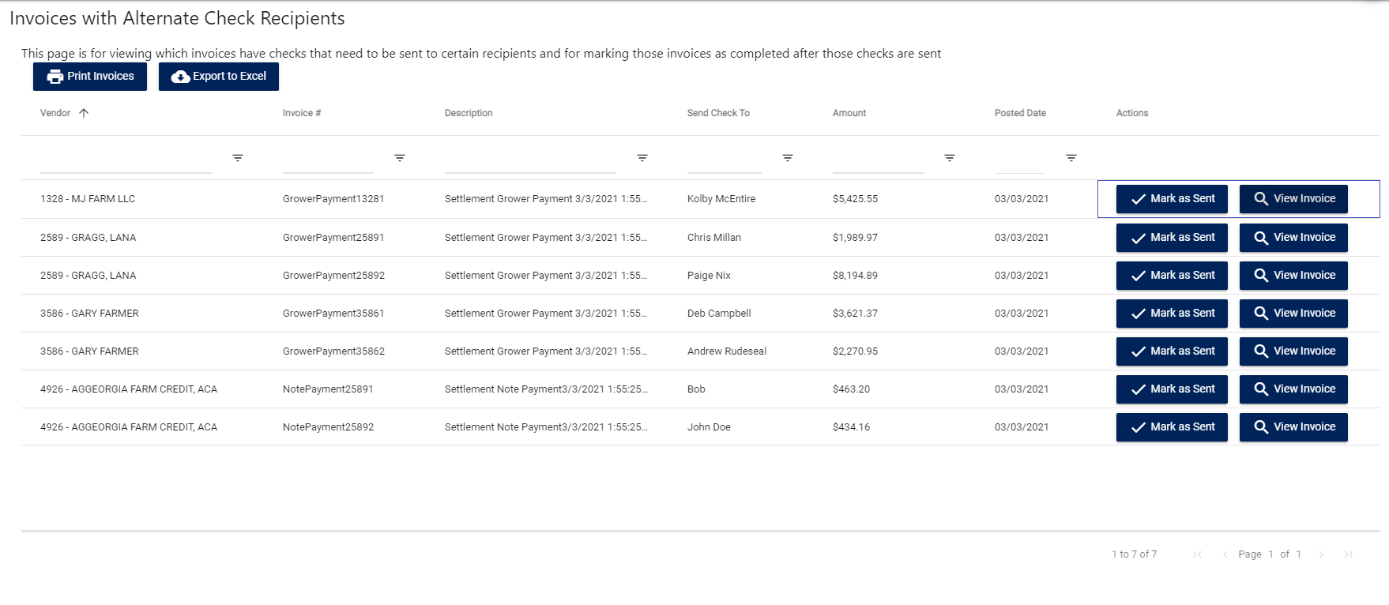

# Reports

The reports section of the site offers multiple reports and inquiries for the end user.

## SQL Server Reports

The SQL Server Reports can be accessed by clicking “Reports” under the “Reports” menu tab. This page contains a list of the main reports for the Grower Accounting system, which can be accessed by clicking on the individual report name

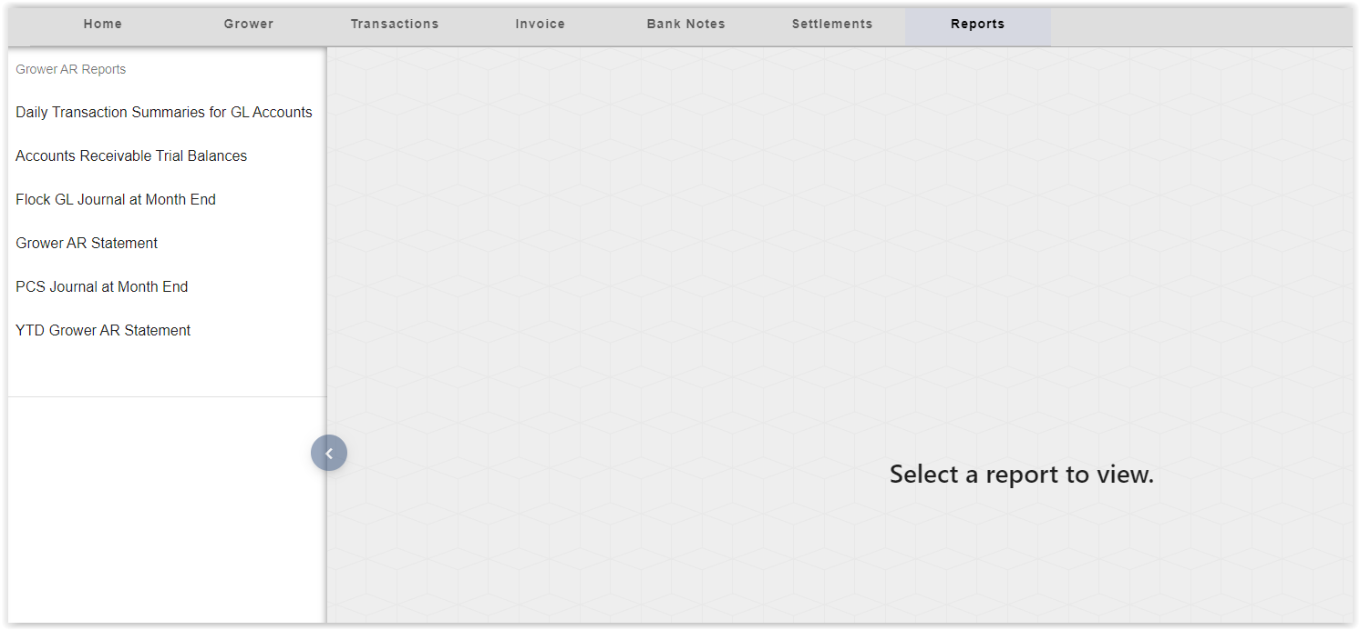

For example this is the Accounts Receivable Trial Balances report

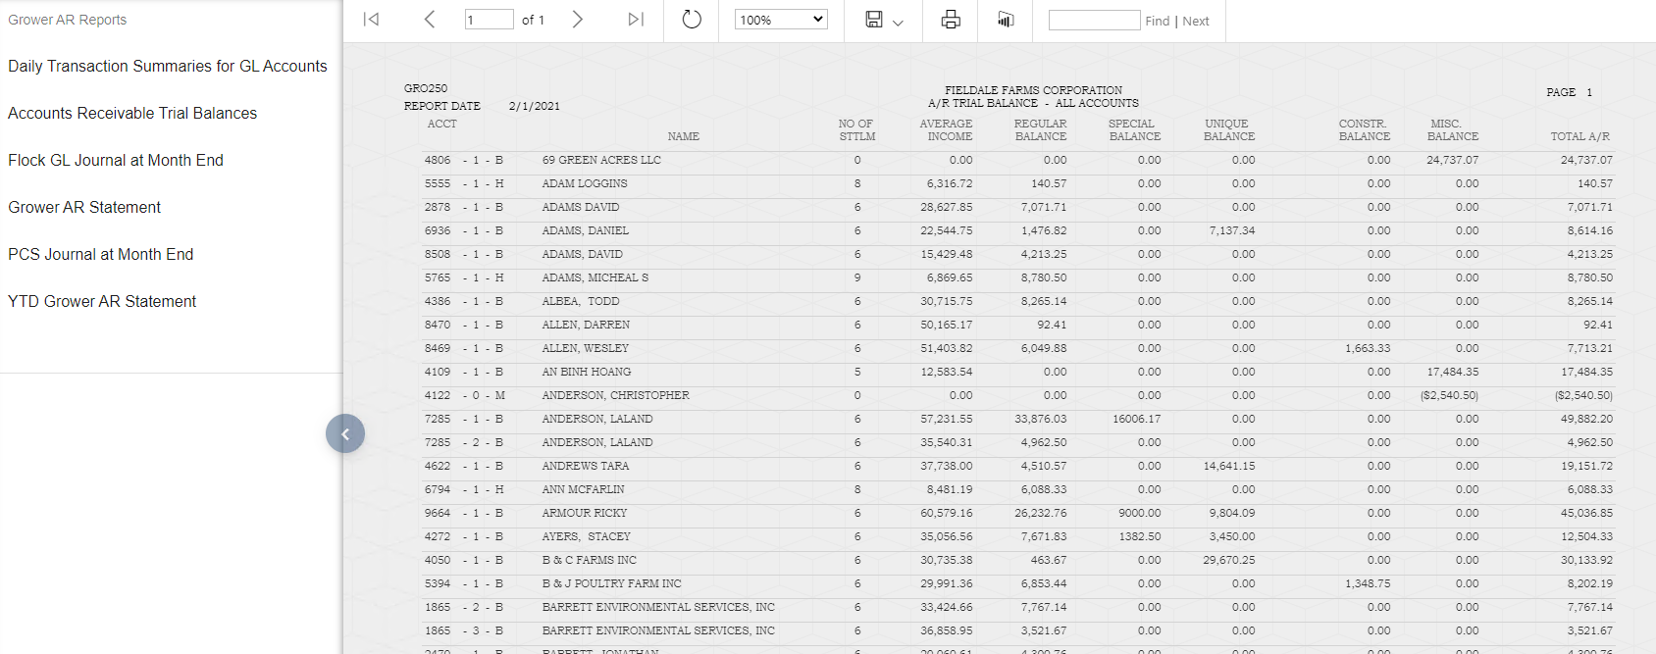

## Credit Inquiry

The credit inquiry page can be reached by clicking “Credit Inquiry” under the “Reports” menu tab. First the user must select a Grower (similar to the other grower selection screens in the Grower Accounting site), then they are given a list of settlements for that grower to select from.

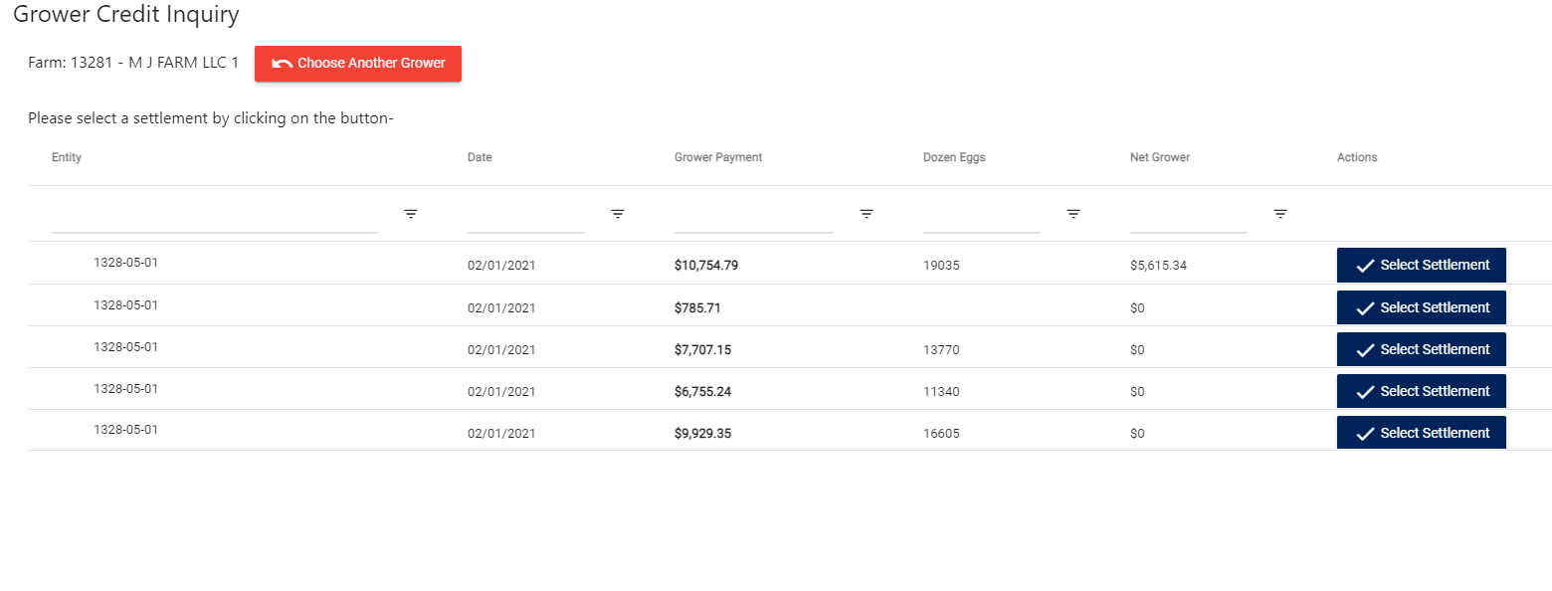

Once they select an individual settlement the page will load the credit inquiry information for that settlement, which also lists out any account deductions (charges/credits) and note payments made during that settlement.

